**Known Vacancies**

EEs will submit their names to be considered for blocks of overtime in their shift and job code for however much they want within 2-14 days of when they are logged in. They can submit their names for overtime blocks regardless of whether there is a need or not. EEs can withdraw their overtime submissions but not within 2 days of the overtime block.



Above is an example of a 12 day period of what overtime might look like. EEs have marked the days they would be willing to work overtime and the system has ordered them to show which is most eligible for each position.

When an EE submits for overtime they will have a comment box to specify which position they would prefer to work. This is so the SS can accurately assign jobs before a shift starts.

When the 2 day deadline arrives the system will lock for that date and a SS will review the submissions and award the overtime to the EE that the system found to be the most eligible.

To recognize which of the submissions is ‘most eligible’ the system will gather the submissions, check for off-going shift, opportunity overtime hours, and seniority at that position. If there is a tie then it will choose the submission with the oldest date.

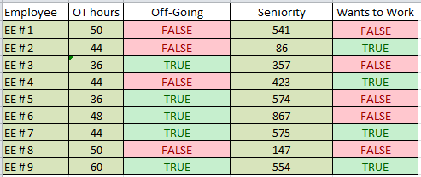

The most eligible EE in the above list would be EE # 7. EE # 7 is on the off-going shift, has the lowest overtime hours, is willing to work, and has seniority over the only other EE who is eligible.

An EE will accumulate opportunity overtime hours by filling overtime slots AND not filling overtime slots that they could have.

Once an EE has been awarded overtime by the SS an email will be sent to the EE.

**Options**

1. The email will have an ‘Accept’ and a ‘Decline’ button. Once an EE has accepted the overtime they must work it. If the EE does not respond within 12 hours then the overtime will be considered declined.
2. The email will have only a ‘Decline’ button. The EE will have 12 hours to decline the overtime else they are considered to have accepted it.
3. The email will have no buttons and will just inform the EE that they have been award the overtime.

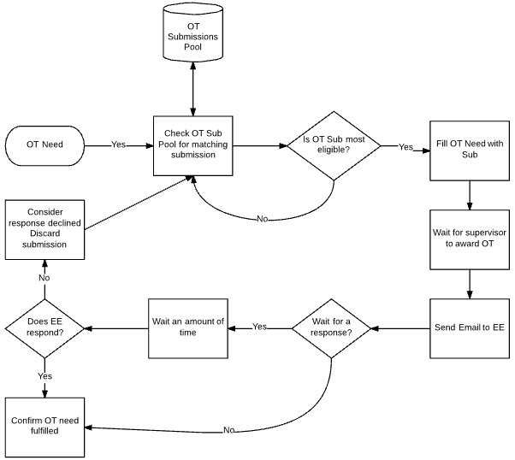

**Unknown Vacancies**

Unknown vacancies are overtime needs that are usually caused by call-outs that appear on day 0. These overtime needs can be handled by the system. The only thing that will change is the ‘want to work’ status.

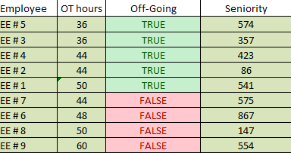

When an unknown vacancy pops up a SS can pull up a list of the most eligible EEs for that job code. The SS can then approach these EEs and offer them the overtime. In the above list EE # 5 would be the first name on the list because they are off-going, have the least overtime hours, and EE # 5 has seniority over EE # 3 who would be the next on the list. If EE # 5 refuses the overtime then the SS would move on to the next EE on the list.

When an EE has accepted the overtime the SS can enter them into the system the same way an EE would. SS can leave a comment to be used in the report they can later print.

If the SS goes through the list of off-going EEs they will then need to move on to the oncoming. The SS will be shown the phone numbers for these EEs and can call them. If no employee can be found to fill the vacancy then the SS will have to mandate overtime to EEs pulling from the off-going shift and the oncoming shift.

**Other Functionality**

* For EEs the SS is trying to contact to fill unknown vacancies, the SS will be shown their phone number to be able to easily contact them.
* An EE who is not interested in working overtime can set their account to a ‘Never Call’ status so that their name will not show up in overtime eligibility lists. An EE who is under the ‘Never Call’ will still accumulate opportunity overtime hours.
* An EE can see the overtime that has been awarded to other employees and whether or not they have accepted the overtime. If an EE knows that they were the next ‘most eligible’ then this will help them keep track of the possibility of it being awarded to them.

**Scenarios**

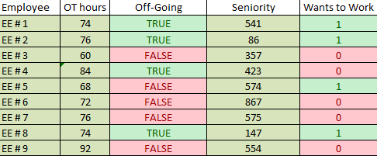

1. There are 2 overtime needs and the system needs to make a list of the most eligible EEs. It will check off-going, willingness to work and then OT hours. The first name it grabs is EE # 1 because the Seniority of EE # 1 his higher than EE # 8. EE # 8 will be second then EE # 2 and 5.

Employee OT Hours Off-Going Seniority

EE # 1 74 TRUE 541

EE # 8 74 TRUE 147

EE # 2 76 TRUE 86

EE # 5 68 FALSE 574

The SS will then get this list with all the information to show why it made the list this way and the SS will choose the most eligible EE. In this case it’s EE # 1. In this scenario there are 2 overtime needs to be filled so the SS will also award overtime to EE # 8.

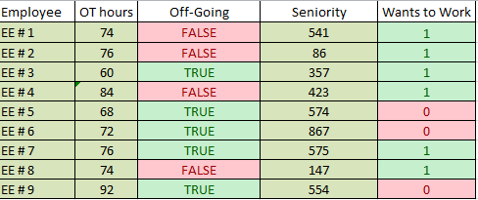

1. In this scenario there is only 1 overtime need. The system will make a list of the most eligible employees.

Employee OT Hours Off-Going Seniority

EE # 3 60 TRUE 357

EE # 7 76 TRUE 575

EE # 1 74 FALSE 541

EE # 8 74 FALSE 147

EE # 2 76 FALSE 86

EE # 4 84 FALSE 423

The list generated is of all the employees who submitted their name to be considered for the overtime slot. Since there is only 1 overtime need the SS only chooses EE # 3.

The supervisor working the shift before this one starts discovers there is an unknown vacancy and needs another employee to work overtime.

Employee OT Hours Off-Going Seniority

EE # 5 68 TRUE 574

EE # 6 72 TRUE 867

EE # 7 76 TRUE 575

EE # 9 92 TRUE 554

The supervisor is then given a list of the eligible employees regardless of the ‘want to work’ status. EE # 3 is left off the list because they are already working overtime on the next shift.

The SS now needs to go through this list and offer the overtime to the EEs. EE # 5 and EE # 6 decide that they do not want the overtime. The SS asks EE # 7 and they accept the overtime. The SS puts them into the system and asks them what position they would prefer so a report can be printed of all the EEs coming to work overtime and their preferred positions.